Created the folder ArchOSC Assignment inside the Workspace folder. Created the Pictures folder and Lab 2 placeholder word document inside of the ArchOSC Assighnment folder. Took a screenshot of the condense of the ArchOSC Assignment folder and saved it as screenshot 1 inside the pictures folder.
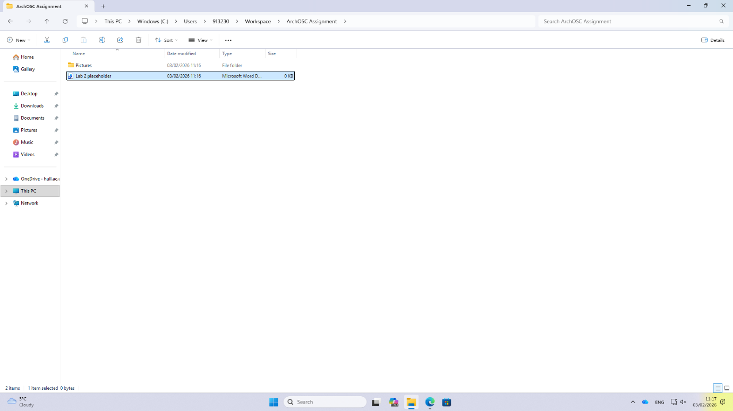

Opened the terminal within the ArchOSC Assignment folder and used the git init command to initialise a local repository using this folder.
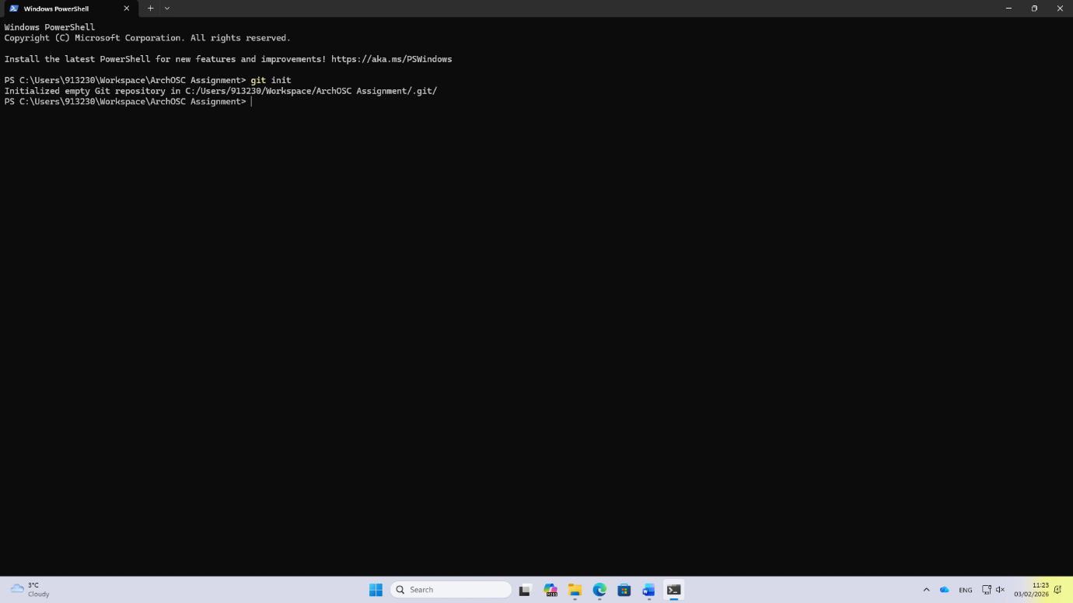

Created a GitHub repository in the GitHub website with the name ArchOSC-Assignment-AndrewBell.
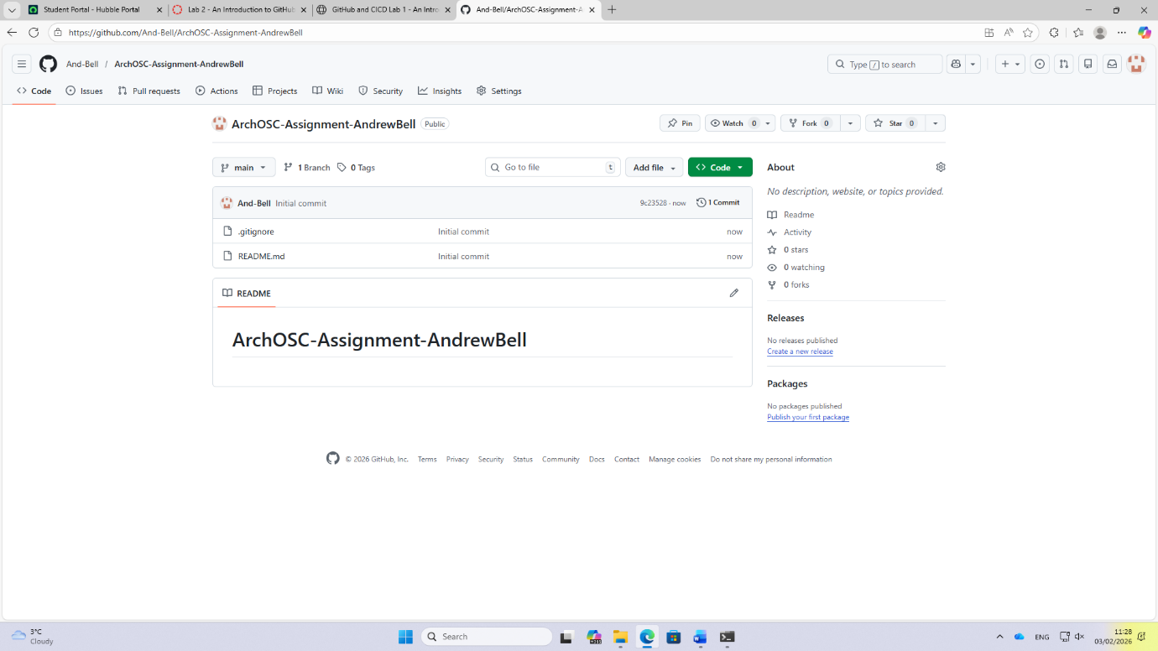

Used the terminal commands git remote add origin and git pull origin main to link the GitHub repository with the local repository then pulled the files from the GitHub version to the local version.
